

**TRIMESTER 1 2019/2020**

**TSA2131 - System Analysis and Design**

**Smart Parking System**

Lecture Secion: SA1

Project Group 7F

|  |  |  |
| --- | --- | --- |
| **Student ID** | **Student Name** | **Major** |
| 1161103561 | Eugene Low Chun Chuan | AI |
| 1151105412 | David Ang Huang Qiang | AI |
| 1161104276 | Brian Justin Santiago | AI |
| 1161103503 | Justin John Rajoo | AI |
| 1161104086 | Tang Jian Ern | AI |

FACULTY OF INFORMATION SCIENCE & TECHNOLOGY

MULTIMEDIA UNIVERSITY MALAYSIA

3 OCTOBER 2019

**Table of Contents**

**I.** **Requiremenet Determination** 2

i. Introduction 2

ii. Project Charter 3

iii. Baseline Project Plan 5

iv. Project Scope Statment 9

v. Cost-Benefits Analysis 11

vii. Literature Study 16

**II.** **Requirement Structuring** 22

i. Data Flow Diagrams (DFD) 22

ii. Use Case Modeling 23

iii. Conceptual Data Modeling (E-R diagram) 24

**III.** **System Design and Implementation** 25

i. Relational data model with normalization 25

ii. Interface Design 27

iii. Design Specifications 33

iv. Dialogue Diagram 35

v. Usability Success Factor 36

**IV.** **Conclusion** 37

**V.** **References** 38

# **Requiremenet Determination**

## Introduction

Traffic congestion caused by vehicle is an alarming problem at a global scale and it has been growing exponentially. Car parking problem is a major contributor and has been, still a major problem with increasing vehicle size in the luxurious segment and confined parking spaces in urban cities. Searching for a parking space is a routine (and often frustrating) activity for many people in cities around the world. This search burns about one million barrels of the world’s oil every day. As the global population continues to urbanize, without a well-planned, convenience-driven retreat from the car these problems will worsen.

Smart Parking systems typically obtains information about available parking spaces in a particular geographic area and process is real-time to place vehicles at available positions. It involves using low-cost sensors, real-time data collection, and mobile-phone-enabled automated payment systems that allow people to reserve parking in advance or very accurately predict where they will likely find a spot. When deployed as a system, smart parking thus reduces car emissions in urban centers by reducing the need for people to needlessly circle city blocks searching for parking. It also permits cities to carefully manage their parking supply smart parking helps one of the biggest problems on driving in urban areas, finding empty parking spaces and controlling illegal parking.

Our smart parking system is made up of interchangeable components and fully integrates parking, guidance, payment and analytics as well as host of other complementary services and options. Users are able to book a parking in advance and pay the parking fee by using our smart parking system.

## Project Charter

|  |
| --- |
| Project Group 7F Prepared: July 21, 2019  Project Charter |
| **Project Name:** Smart Parking System  **Project Manager:** Eugene Low Chun Chuan |
| **Customer:** Marketing  **Project Sponsor:** Public  **Project Start/End (projected):** 15/7/19 - 30/9/19 |
| **Project Overview:**  This project will implement a smart parking system for the drivers outside. The purpose of this project is to let the drivers can find and book an empty parking slot in advance easily. As a result, this can save drivers’ time and to improve the safety on the road. |
| **Objectives:**   * To improve the accuracy of information about parking slot * To overcome the limitation of the conventional payment methods by revamping the payment method via parking meter * To enable users to book the parking slot at their desire time.   **Key Assumptions:**   * SmartCloud that gathers and processes information. * Service Packs that provides access to real-time information by using SmartCloudAPI interface. * Parking App that shows clear, real-time guidance and payment and embeddable map. * SmartSpots that provide an IoT gateway in a single unit, allowing hundreds of different devices to connect. * Vehicle Detection Sensors to suit the needs of different sites. These robust and scalable devices monitor bays and relay live status information to SmartCloud. * Automatic number plate recognition (ANPR) is one of the most cost-effective and efficient ways to manage an off-street car park.   **Stakeholders and Responsibilities:**  **Stakeholder Role Responsibility**  Eugene Low Project Manager Planning, Monitoring, Executing Project  David Ang Interface Designer Design system interface  Justin John Interface Designer Design system interface  Tang Jian Ern Tester Test the system  Brian Santiago System Analyst Research, Analyze |

## Baseline Project Plan

|  |
| --- |
| **BASELINE PROJECT PLAN REPORT** |
| * 1. **Introduction**  1. Project Overview   The hassle of finding a car park in the right time and place will be solved with the help of Smart Parking.  Upon completion of the prelimanary investigation, Smart Parking has found the proposed system design to be ecnomically, technically, political and opeartionally feasible. It is feasible in terms of legal and contractual obligations as well. There is no substantial economic cost to be sustained at any point of the implementation process. There is no need for the hiring of additional staff and it doies not call for capital expenditure. The proposed system works within the scope of Malaysia patent law and within the terms of all union and vendor conrtacts involved. Newly designed workflows do not significantly disturb current operational processes. Lastly, there is not much of political interface.  The main motivation behind this project is saving the time of our users finding a parking spot. Additionally, to reduce carbon emission by reducing the needs to circle city blocks to search for parking. To keep the two in a parallel fashion, smart parking will be a better and superior solution today. Smart parking is an additional added administrative arrangement in itself, only a small group of individuals will be needed to maintain all the functionalities of the application.  The resource requirement are labours, database, sensors and software  This project is estimated to be completed within 2.5 months from July 17.   1. Recommendation   Circling around a city without finding a parking spot is common. In urban areas, parking could be limited and not convenient to find. On the other hand, empty parking spaces are often occupied due to the large volume of vehicle. Thus, Smart Parking enable users to reserve available parking spot with a real time GPS and suggest a suitable time for users to take up a parking spot. |
| 1. **System Description** 2. Alternatives   This revolution in parking includes the provision of real-time parking data to citizens, as well as the instant regulation of parking areas.  The technology might include guidance systems helping visitors to spaces in your company car park – or better still – at the local supermarket. It also gives an option for users to pay their parking fees on the application.   1. System Description   The system will be integrated into the Apps Store and Google Play. Firstly, users who wants to have ease of finding parking spots will be required to download it in either platform. Next, the application will bring users to an interface where users can find an empty parking spot. Once users have booked their spots, there is a GPS guiding them to their location. On top of that, the application will suggest when is the best times to park their car based on histories of peak hours and current traffic situation. |
| 1. **Feasibility Assessment** 2. Economic Analysis   This section will identify both the financial benefits and costs associated with the recommended system. Smart Parking will experience tangible and intangible benefits from implementing the system.  **Tangible benefits include:** cost reduction or avoidance, error detection, increase flexibility, increase speed of activity, improve in management planning or control  **Intangible benefits include:** enhance user experience, improve organisational planning, improve the safety on the road, discover the trend about the parking area, reduce road range and frustration  **One-time cost:** development costs, new hardware and software, user training, site preparation  **Recurring cost:** application software maintenance, incremental communications, new software or hardware leases, supplies   1. Technical Analysis   This section will identify risk factors associated with the recommended systems. The failure to evaluate risks may result in consequences. The selected system comprises the process of finding a car park and suggest what is the best time for users to enter the area of parking spot, however, it presents the following risks.   1. Operational Analysis   Negotiations will bedone across the country with shopping malls, relevant parking spaces, public parking spots and hotel reservations spots wich will be done by Justin John. Firstly, Eugene as the project manager will start planning, monitoring and executing. Brian Santiago as the system analyst will do the research on existing systems and determine the users’ requirements. Then, David and Justin are responsible on designing the system interface. Lastly, Jian Ern as the tester will test the interface and gives some feedbacks about the system interface.   1. Legal and Contractual Analysis   The main regulatory law on road transportation in Malaysia is the Malaysian Road Transport Act since 1987. Provisions against third party risks that arise out of the use of motor vehicles- referring to insurance and the duties of insurers as well as the rights of third parties against insurers; also included here is the settlement between insurers and the insured individuals and the conditions in which third-party claims are not affected by bankruptcy.   1. Political Analysis   Theway our company is going to maintatin a relationship with all of the stakeholder is to hold frequent meetings and skype calls. |
| 1. **Communication Plan**  |  |  |  |  |  | | --- | --- | --- | --- | --- | | **Types** | **Members/Stakeholders** | **Communication Methods** | **Date** | **Notes/Outcome** | | Meeting | All members | Face-to-face | 20/07 | Project Plan and work assignment | | Meeting | All members | Whatsapp Call | 11/08 | System analysis and requirement structuring | | Meeting | All members | Face-to-face | 08/09 | System design and implementation | |

## Project Scope Statment

|  |
| --- |
| **Project Group 7F** Prepared by: Eugene Low **Project Scope Statement** Date: July 21, 2019 |
| **General Project Information**  **Project Name:** Smart Parking System  **Sponsor:** Public  **Project Manager:** Eugene Low Chun Chuan |
| **Problem/Opportunity Statement:**  Nowadays, there is an ever-increasing number of vehicles. This is leading to drivers have the difficulties to find an available parking slot to park their car. The process of looking for a parking lot is time consuming, confusing and wasting fuel as well. This might cause frustration or bad mood for the drivers. The side effect of this problem is serious and need a better solution to handle it. |
| **Project Objectives:**  To develop a wireless communication system, sensor, programming parking system for drivers and management. This will also provide a better parking management system and booking system for car park. |
| **Project Description:**  A new system will be constructed that will provide a better image processing and range sensors to improve the accuracy of information or available parking slot and the location of the available parking slot for drivers. The project will follow PVF’s systems development life cycle. |
| **Business Benefits:**   * Accurately predict and sense spot/vehicle occupacy in real-time. * Help traffic in the city flow more freely leveraging IoT technology. * Enables intelligent decisions using data, including real-time status applications and historical analytics report. * Create better urban environment by reducing the emission of CO2 and othe pollutants. * Enables better and real-time monitoring and manging of availbale parking space |
| **Project Deliverables:**  Smart parking system analysis and design  Smart parking system programs  Smart parking system documentation |
| **Estimated Project Duration:**  2.5 months |

## Cost-Benefits Analysis

1. Tangible Benefit

|  |
| --- |
| TANGIBLE BENEFITS WORKSHEET  Smart Parking System Project  Year 1 through 5   1. Cost reduction or avoidance RM 4500 2. Error reduction 2500 3. Increased flexibility 7500 4. Increased speed of activity 10500 5. Improved in mangement planning or control 25000 6. Other 0   **TOTAL tangible benefits RM 50000** |

1. One-Time Costs

|  |
| --- |
| ONE-TIME COSTS WORKSHEET  Smart Parking System Project  Year 0   1. Development costs RM 20000 2. New hardware 15000 3. New(purchased) software, if any 4. Packaged applications software 5000 5. Other 0 6. User training 2500 7. Site preparation 0 8. Other 0   **TOTAL one-time costs RM 42500** |

1. Recurring Costs

|  |
| --- |
| RECURRING COSTS WORKSHEET  Smart Parking System Project  Year 1 through 5   1. Application software maintenance RM 25000 2. Incremental data storage required: 20 GB x RM50 1000   (estimated cost/MB = RM50)   1. Incremental communications 2000 2. New software or hardware leases 0 3. Supplies 500 4. Other 0   **TOTAL recurring costs RM 28500** |

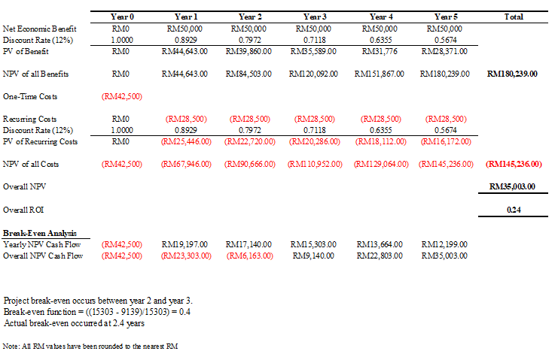

1. Project Schedule

|  |  |
| --- | --- |
| **ACTIVITY** | **PRECEDING ACTIVITY** |
| 1. Planning 2. Requirements Collection 3. Screen Design 4. Report Design 5. User Documentation 6. Implementation 7. Testing 8. Installation | **-**  1  2  2  2,4  3  6  5,7 |

Sequence of activities within the project

Network Diagram

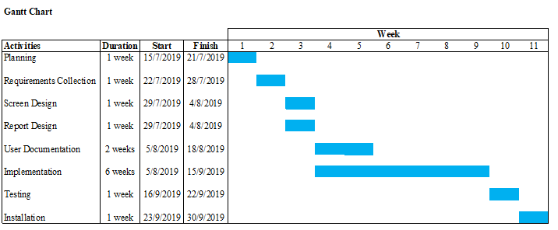

## Literature Study

**Parking.sg**

[*https://play.google.com/store/apps/details?id=sg.parking.streetsmart&hl=en_SG*](https://play.google.com/store/apps/details?id=sg.parking.streetsmart&hl=en_SG)

This smart parking application was developed by Government Techonology Agency to help provide simplicity and convenience to users when they are paying for their parking. This application helps the user pay for their parking from anywhere, anytime and in any weather condition. Users will have to create an account first to use the applicatioin. Once approved they can then use the aplication to help pay for their parking.

**Sample GUI pictures of Parking.sg:**

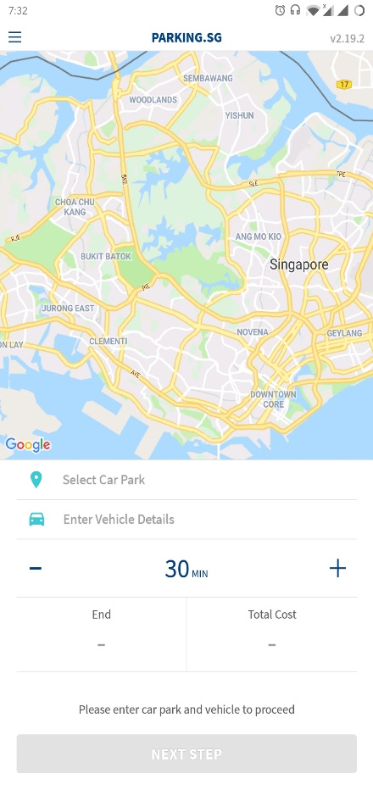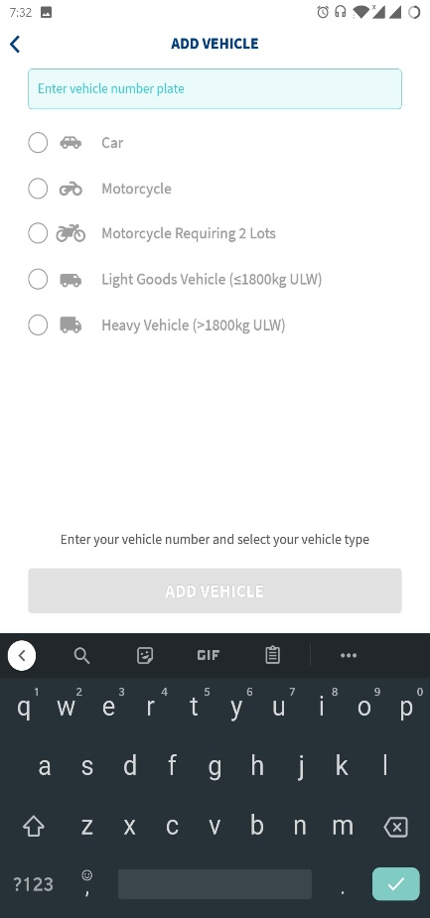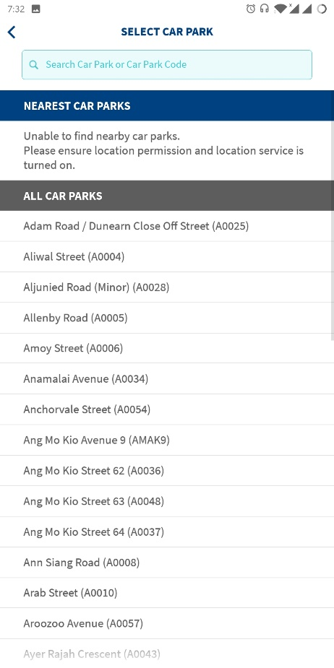

**Advantages:**

* Calculate parking fees automatically.
* Pay for parking digitally.
* Track and extend your aprking seesion remotely.
* Ability to end your parking session early.
* Let’s you pay from anywhere, anytime and can be done by anyone.
* Easy and understandable user interface.
* Simple and easy to use.
* Store multiple vehicles for convenience.

**Disadvantages:**

* Only available in Singopore.
* Application sometimes have diffulty connecting to internet.
* Does not prompt me when my session is expiring.
* GPF function sometimes not working.
* Application sometimes crashes.

**GCC Smart Parking**

[*https://play.google.com/store/apps/details?id=gcc.smartparking.customer&hl=en*](https://play.google.com/store/apps/details?id=gcc.smartparking.customer&hl=en)

Haphazard on-street parking (surface parking) eats into the rapidly diminishing street spaces and footpaths, while obstructing traffic flow and pedestrian movement. All this is about to change as street parking will no longer be free – as these spaces will be charged and regulated, following Greater Chennai Corporation’s public-private partnership with a consortium of service providers for its parking management system, currently under trial. Sources in the Corporation said that in the 471 bus route roads (BRR) and important locations in non-BRR localities, an estimated 12,041 Equivalent Car Space (ECS) has been identified, under the Chennai Smart City initiative.“Camera-based technology will tell the user which slots are empty and the number-plate recognition centre will track the usage. For instance, if a user had parked their car for three hours and paid for that duration, ten minutes before the expiry, an alert will be sent on the app. The user can opt to recharge for an additional hour. The entire system will be automated and smartphone-enabled, but provisions have been made for basic phones and a cash system too”

**Sample GUI pictures of GCC Smart Parking:**

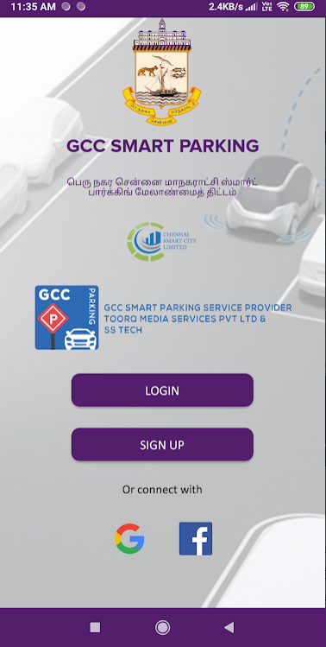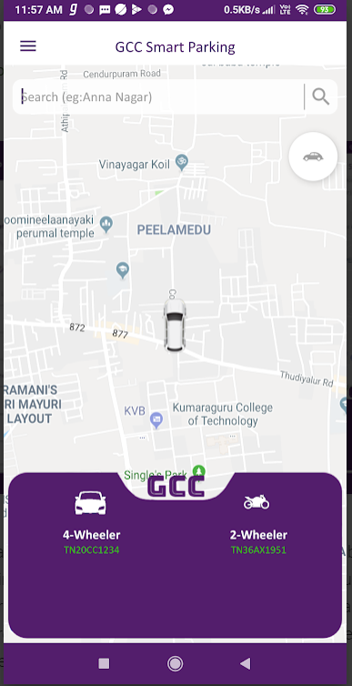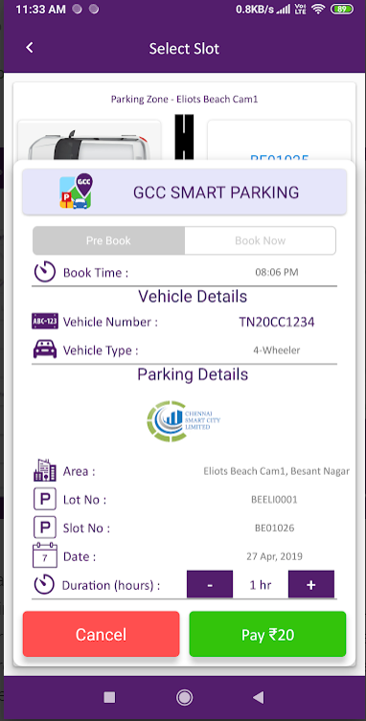

**Advantages:**

* Safe parking space for cards.
* Better traffic flow due to parking management resulting in shorter commuting time.
* Improved liveability.
* Reduction in carbon dioxide emission as vehicles don’t have to circle around neighbourhood for aprking slot.
* Better use of public spaces – for example, as pedestrian spaces.

**Disadvantages:**

* Different paying method.
* Only limit in India.
* Cannot link with any debot/credit card service.
* Cannot be used for any user outside of India.

**SmartParking**

[*https://play.google.com/store/apps/details?id=io.smartsys.master&hl=en*](https://play.google.com/store/apps/details?id=io.smartsys.master&hl=en)

The Smart Parking app helps you find a place to park using live information from the Smart Parking sensor system that has been installed into parking spaces around the city. Using a simple red, amber and, green markers on the live app map, the Smart Parking app provides accurate information about where you are most likely able to find an available parking space. The Smart Parking app reads your smartphone GPS based location then directs you to your chosen parking space location.

**Sample GUI Pictures of SmartParking:**

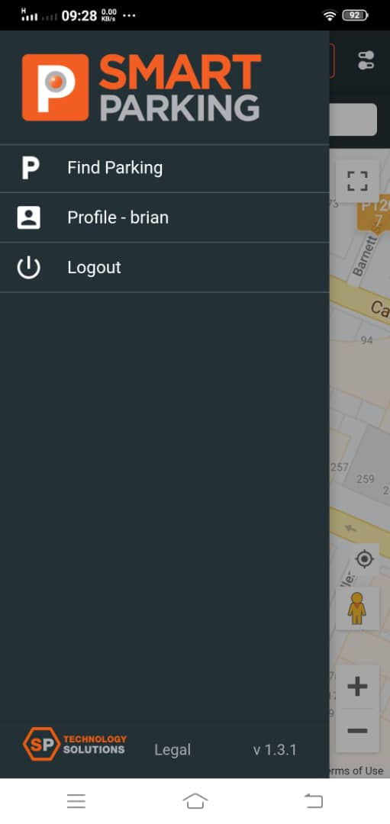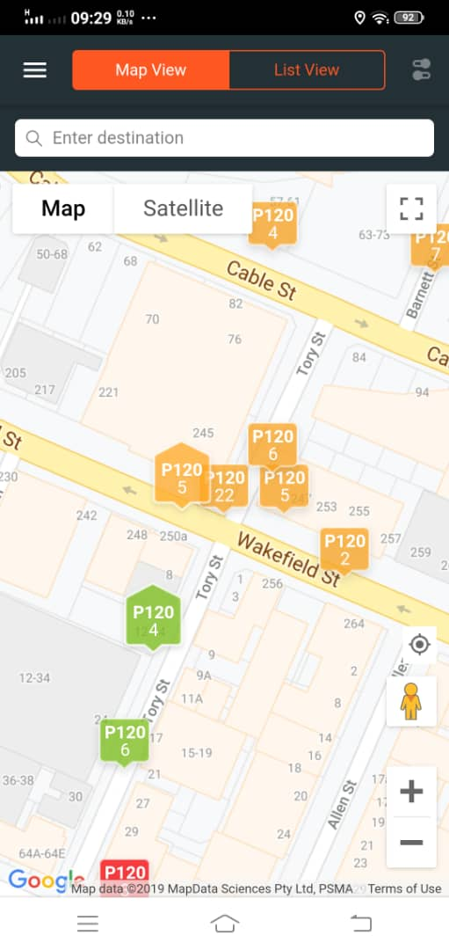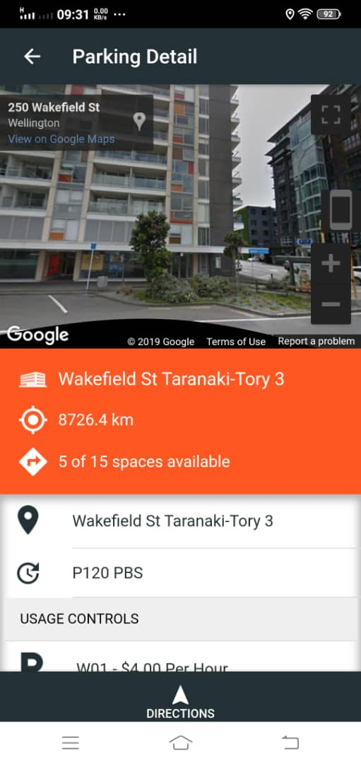

**Advantages:**

* Find car parking based on your current location.
* Real time updates of car park availability.
* Find car parks based on an address search.
* Get turn by turn directions to your selected parking.
* Filter parking options by type.
* View available parking by map or list.
* Connects you to other transport alternatives for your trip.

**Disadvantages:**

* Different paying method.
* Only limit in overseas.
* Can’t check the balance.

# **Requirement Structuring**

## Data Flow Diagrams (DFD)

Context Diagram:

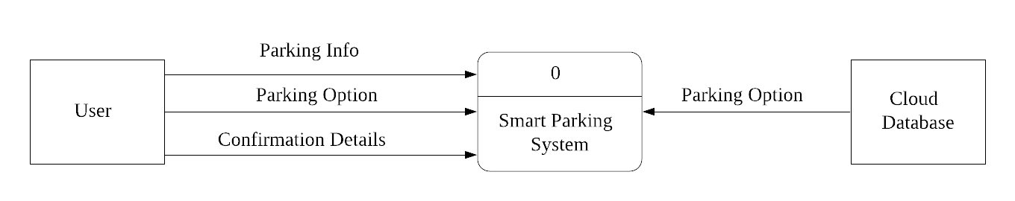

Level-0 Diagram:

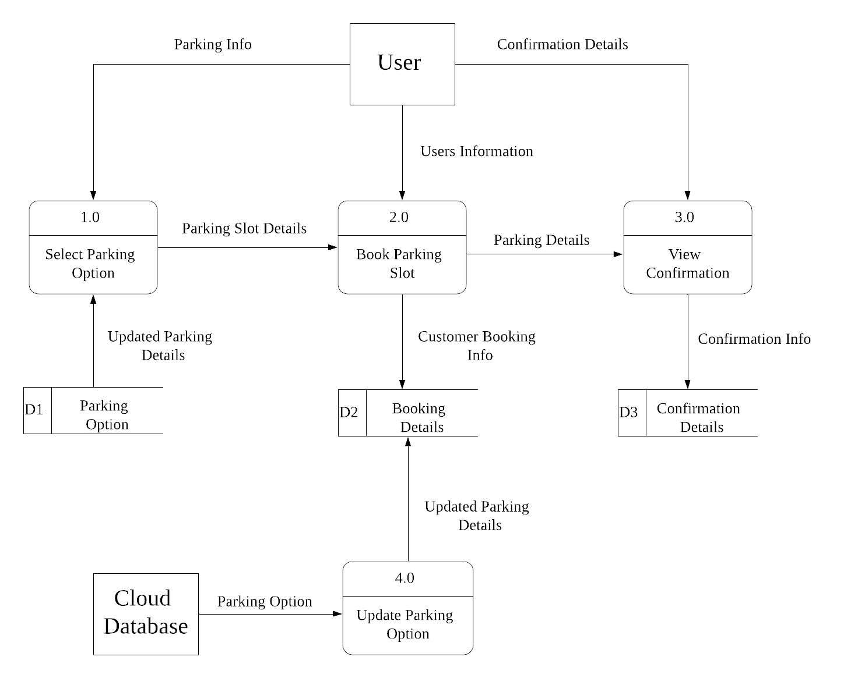

## Use Case Modeling

**Administration**

Municipality

Administrator

Smart Parking System

Smart Parking System

< extend >

< extend >

< extend >

< extend >

< include >

**Operation**

Municipality

Billing provider

Private parking provider

Roadside parking sensor

Data scientist

User

Vehicle

## Conceptual Data Modeling (E-R diagram)

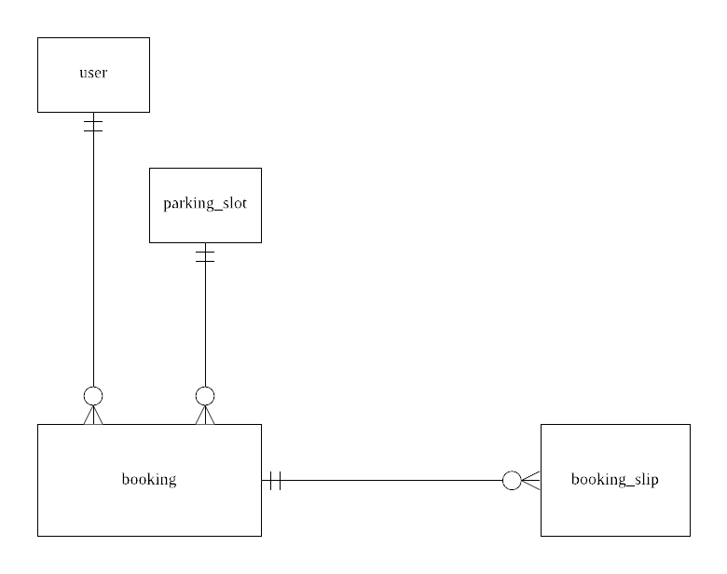

# **System Design and Implementation**

## Relational data model with normalization

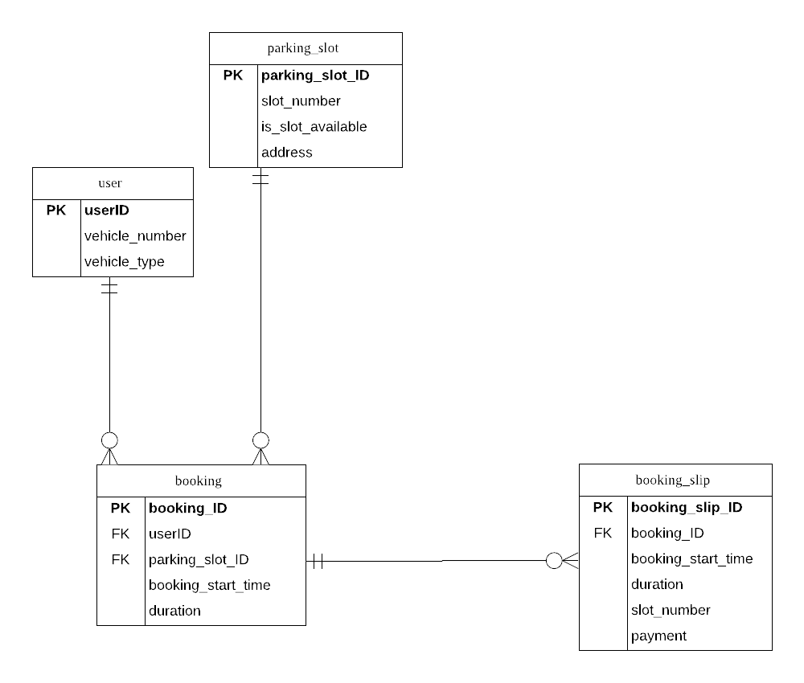

1NF:

booking(**booking_ID**, **userID**, **parking_slot_ID**, vehicle_number, vehicle_type, slot_number, is_slot_available, address)

booking_slip(**booking_slip_ID**, **booking_ID**, booking_start_time, duration, slot_number, payment)

**2NF:**

booking(**booking_ID**, **userID**, **parking_slot_ID**,vehicle_number, vehicle_type)

booking_slip(**booking_slip_ID**, **booking_ID**, booking_start_time, duration, slot_number, payment)

parking_slot(**parking_slot_ID**, slot_number, is_slot_available, address)

**3NF:**

booking(**booking_ID**, **parking_slot_ID**)

user(**userID**, vehicle_number, vehicle_type)

booking_slip(**booking_slip_ID**, **booking_ID**, booking_start_time, duration, slot_number, payment)

parking_slot(**parking_slot_ID**, slot_number, is_slot_available, address)

## Interface Design

 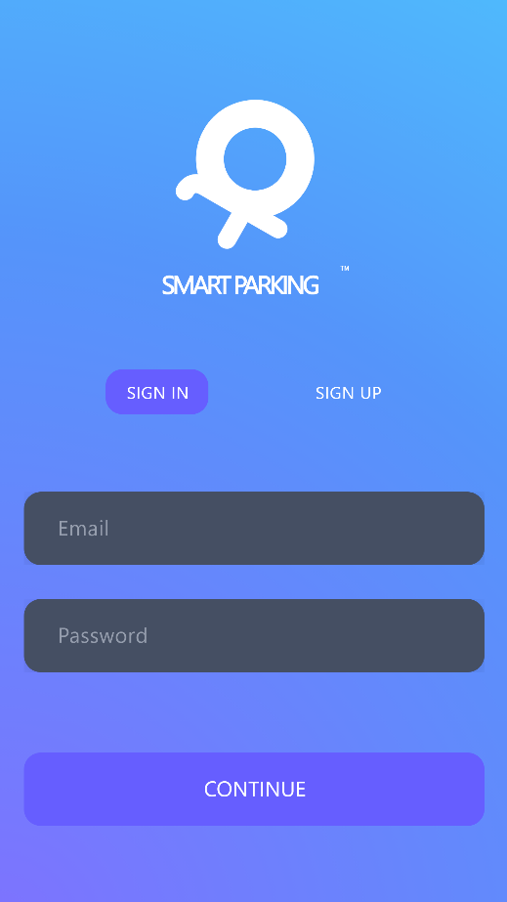

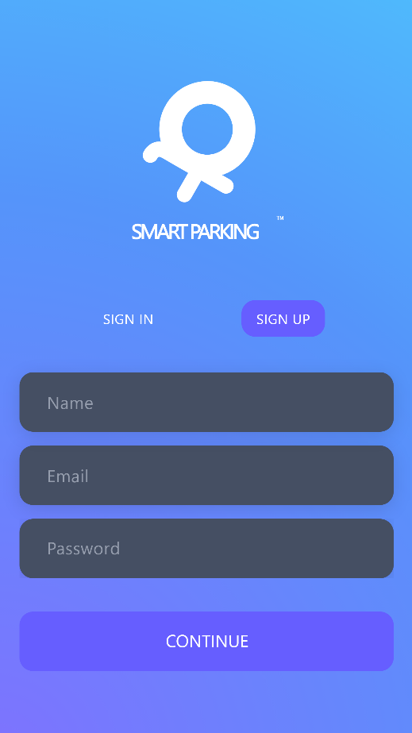 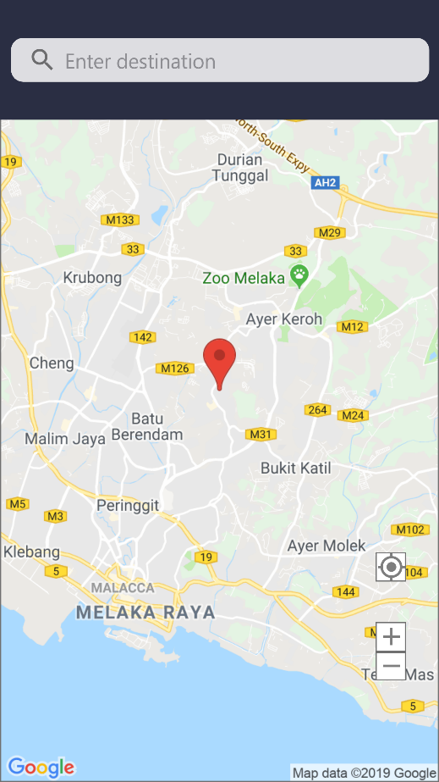

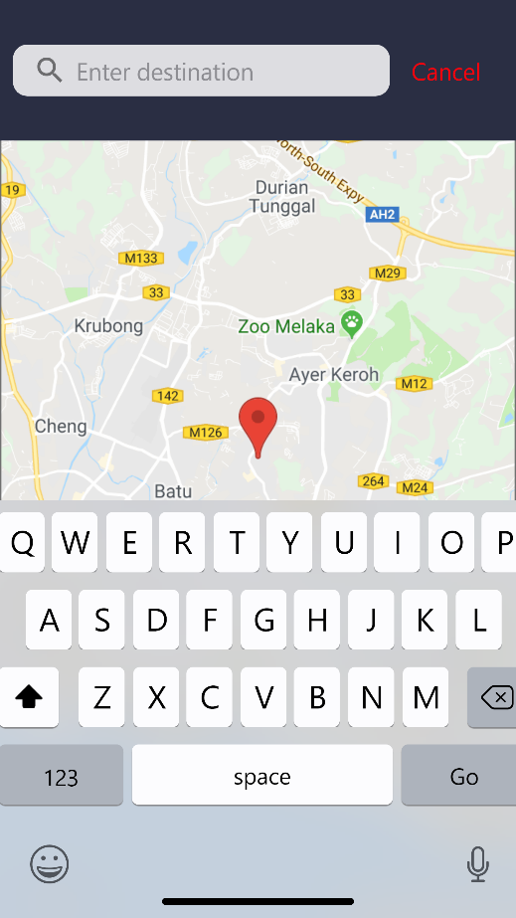 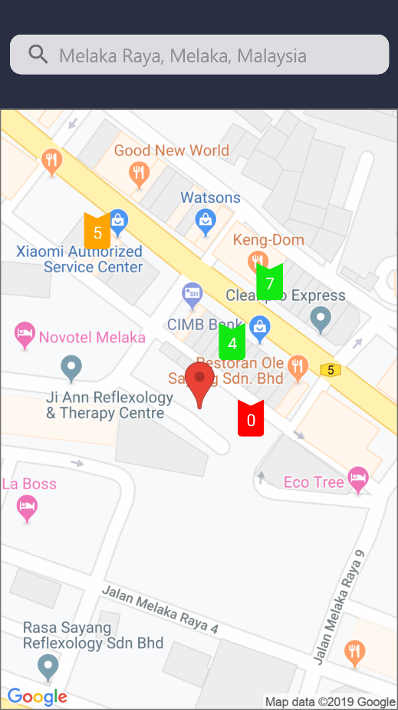

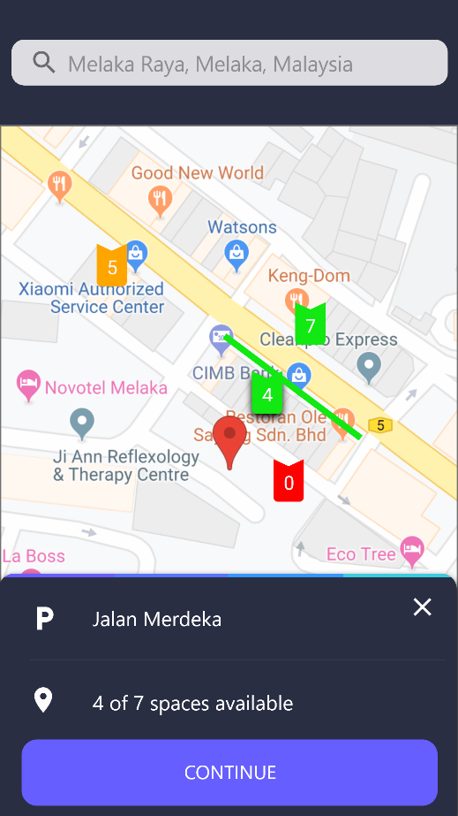 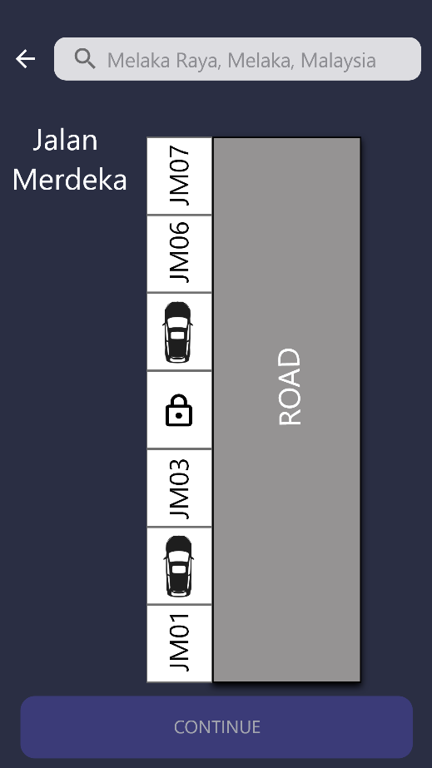

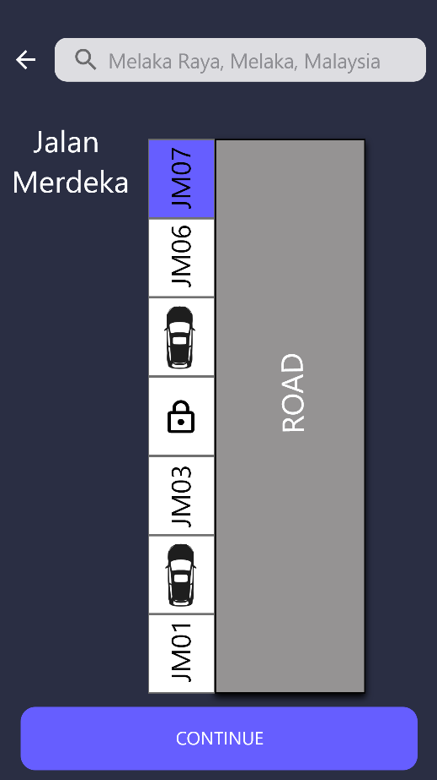 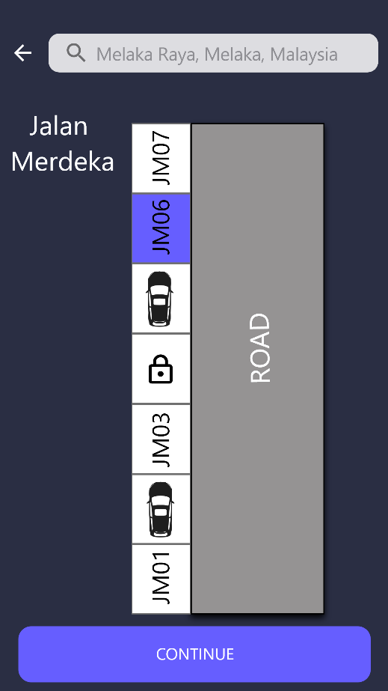

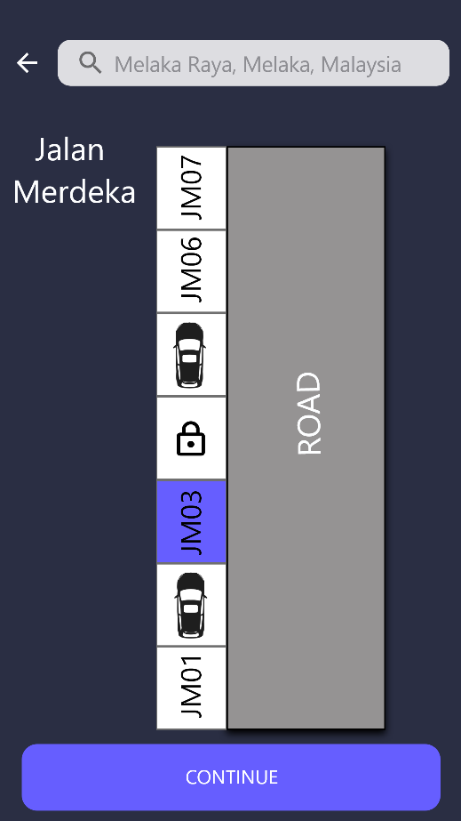 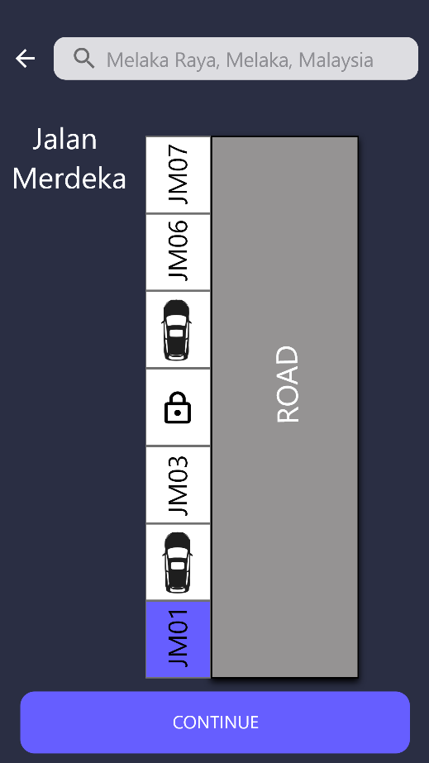

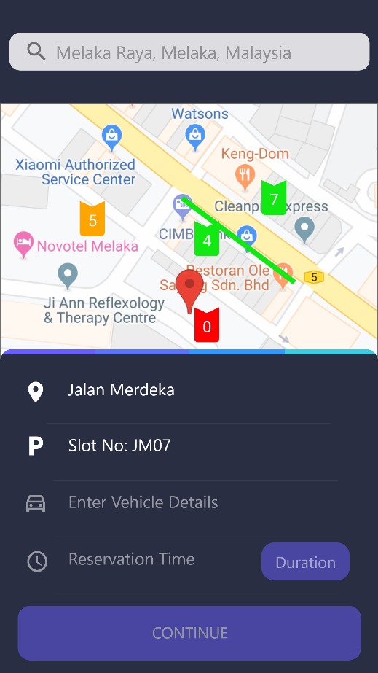 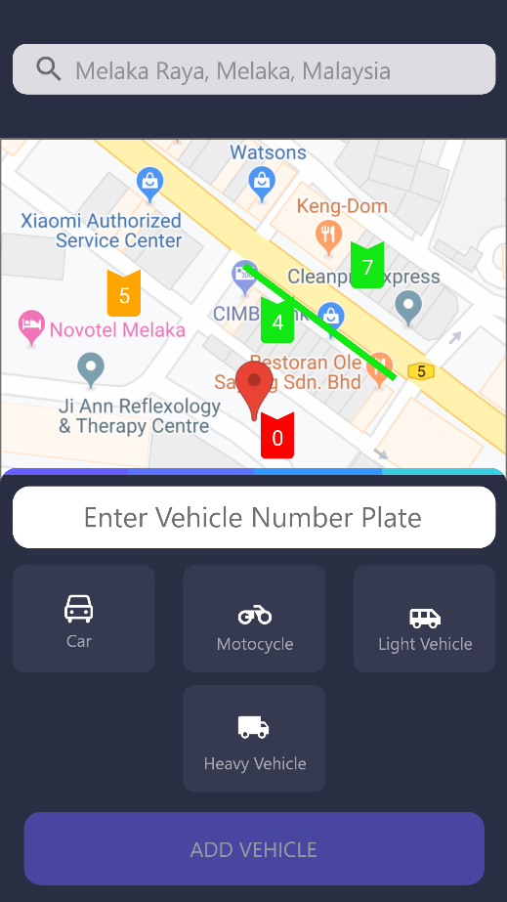

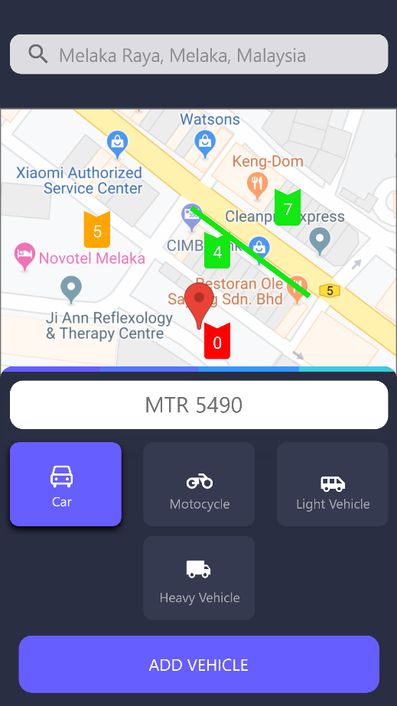 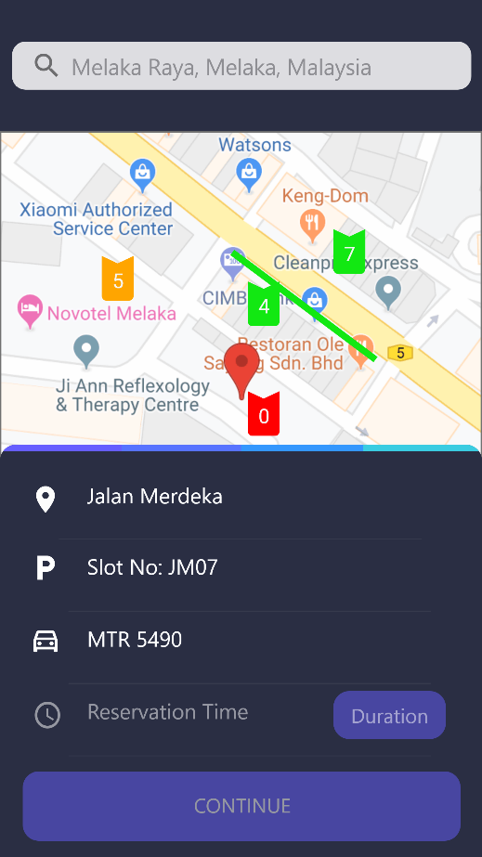

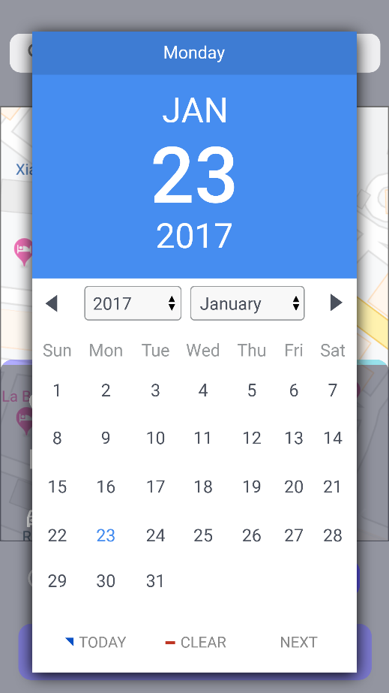 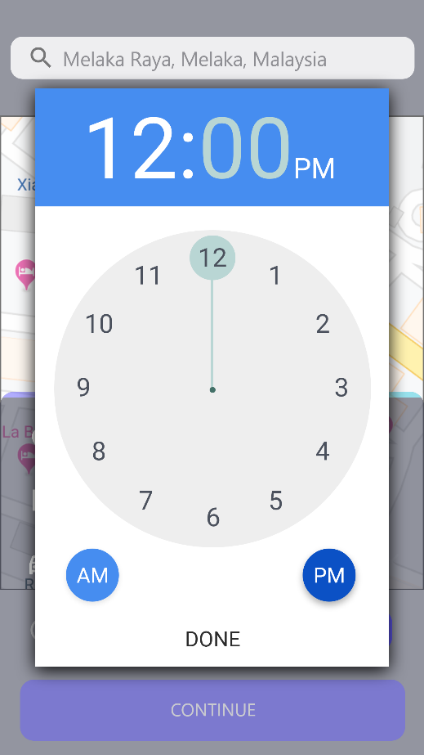

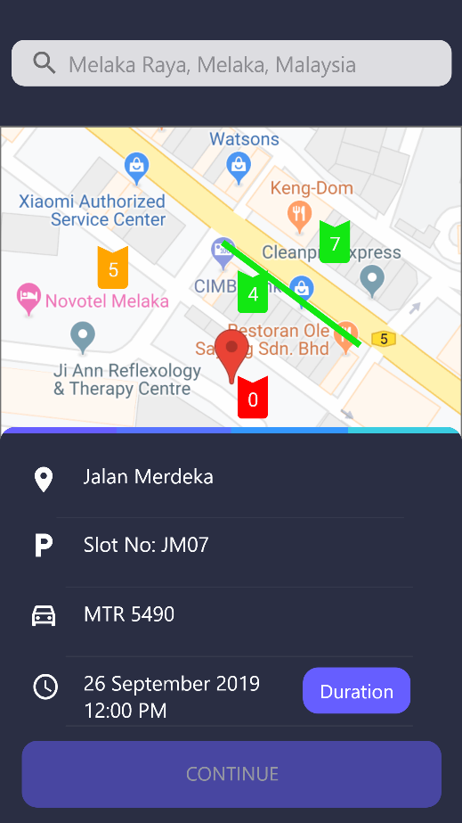 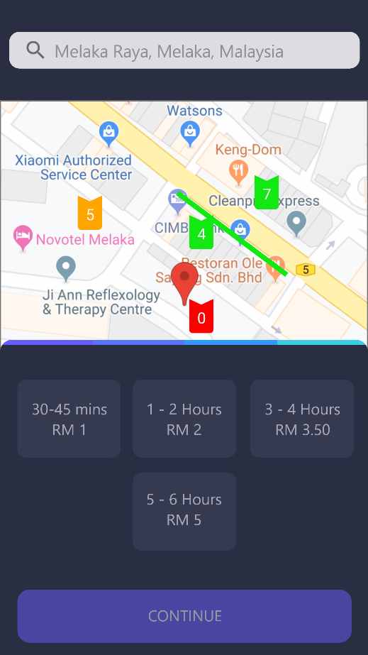

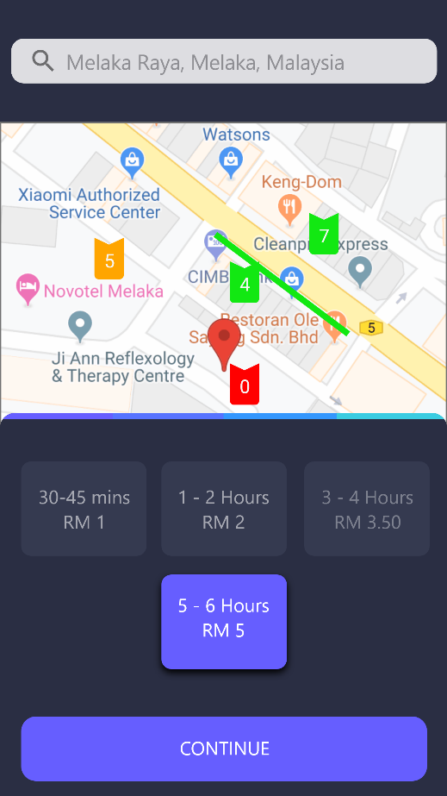 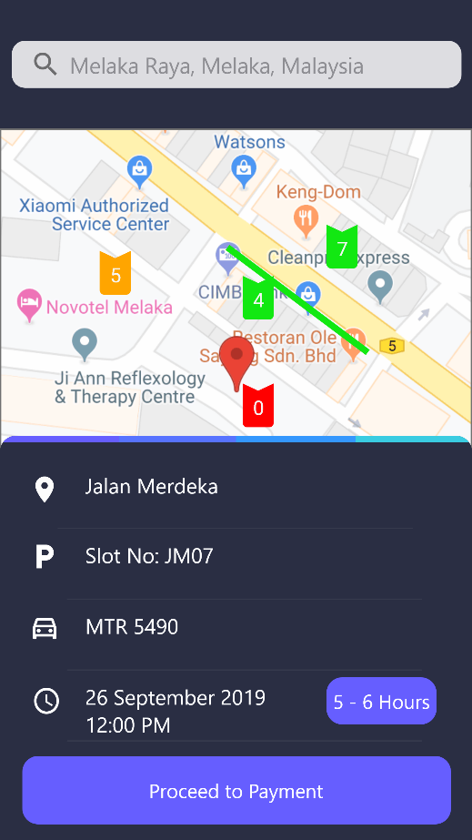

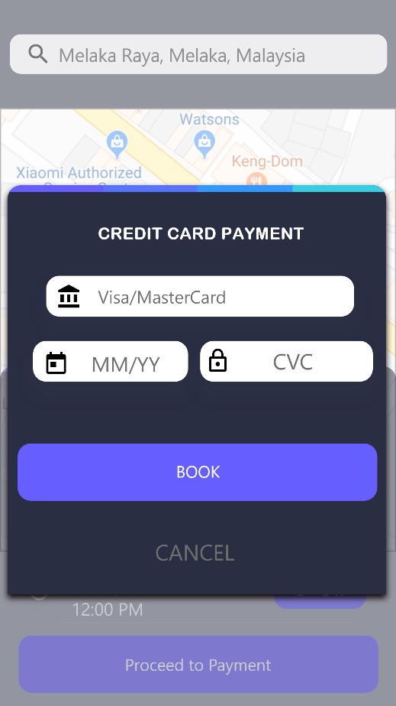 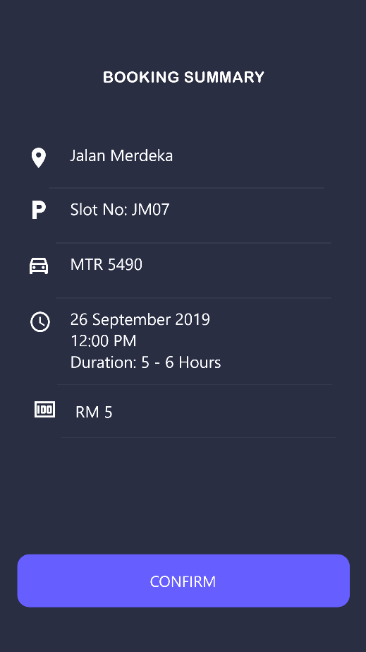

## Design Specifications

|  |
| --- |
| 1. Narrative overview   **Form:** Vehicle Details  **Users:** Customers  **Task:** Enable users to enter their vehicle number plate and choose the vehicle type  **System:** Adobe XD  **Environment:** Public |
| 1. Sample design |
| 1. Testing and usability assessment   User Rated Perception (average 10 users):  Consistency [ 1=consistent to 7=inconsistent]: 1.25  Sufficiency [ 1=sufficient to 7=insufficiency]: 1.12  Accuracy [ 1=accurate to 7=inaccurate]: 1.03 |
| 1. Narrative overview   **Report:** Booking Summary  **Users:** Customers  **Task:** Provide users with information about the booking details.  **System:** Adobe XD  **Environment:** Public |
| 1. Sample design |
| 1. Testing and usability assessment   User Rated Perception (average 10 users):  Consistency [ 1=consistent to 7=inconsistent]: 1.10  Sufficiency [ 1=sufficient to 7=insufficiency]: 1.18  Accuracy [ 1=accurate to 7=inaccurate]: 1.20 |

## Dialogue Diagram

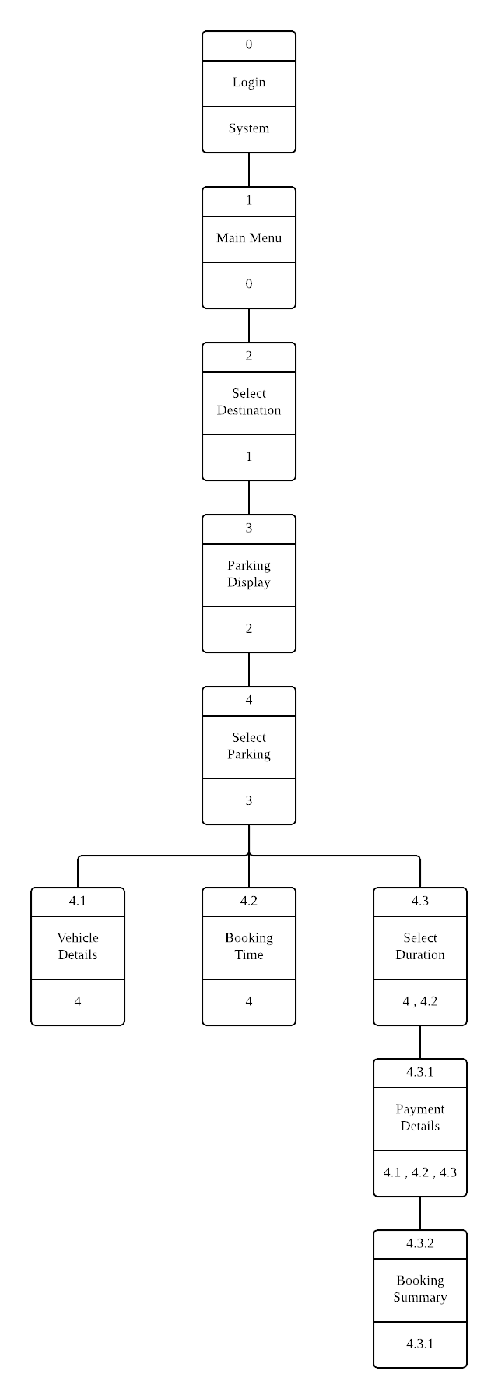

## Usability Success Factor

* 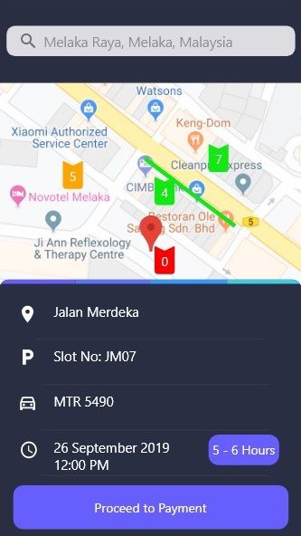**Consistency** – The elements in the user interface are uniform. They create a sense of control, familiarity and reliability.
* **Ease** – The interfaces are easy to use.
* **Efficiency** – Users can proceed to payment by just clicking the button at the bottom and without any extra steps to be performed.
* **Format** – The outputs display in the interface give appropriate informations to the users.
* **Subjective Satisfaction** – It is very recommended to the users to use the application as it provides the informations needed and easy to be used.

The suggestion for future improvement is to enable the system to recommend the time and parking slot for the users.

# **Conclusion**

In this study, the various types of smart parking system and has been presented. From the various examples of the implementation of the smart parking system being presented, its efficiency in alleviating the trafic problem that arises especially in the city area where traffic congestion and the insufficient parking spaces are undeniable. It does so by directing patrons and optimizing the use of parking spaces.

Moreover, Smart Parking System is also a solution to the existing traffic congestion to reduce drivers’ frustration by providing information about the occupancy stuatus of the parking spaces. The system application is user friendly that any user can easily find the status of the parking space and also can set the required date and time to book the parking space. Starting from coming up with the project idea, all this gave us a very good experience and exposure in development of a full stack system application.

Recommendation for future maintenace work

This application is an intial step in reaching the effective solution for the daily concern. This project can extended in multiple ways:

* To provide a central management system that make sure only authenticated information is sent to the client, i.e. dealing with the security issues.
* More analysis can be done using the parking history data by which user can get recommendations or suggestions on parking spaces and their availability trends.

# **References**

SMART PARKING. (n.d.). Retrieved from happiest minds: https://www.happiestminds.com/whitepapers/smart-parking.pdf

SmartPark System. (n.d.). Retrieved from SMART PARKING: https://www.smartparking.com/smartpark-system